MSIS 638

Course Project

Jia Liang Ma

**Which COVID-19 vaccine can be the best choice in the U.S.?**

***Purpose***

This document aims to determine which vaccine is the optimal choice in the current status of vaccines in states, especially in the utility of their performance.

***Scope***

The analysis focuses on the utility of each vaccine available in Boston during the pandemic in 2021. Using the mathematical model to find out the optimal solution as vaccine type based on comparison.

***Introduction and Background***

During the pandemic of COVID-19, immunization is a key factor for global health and medical development, saving millions of lives under the viruses’ outbreak. Vaccines reduce the chance of getting disease by reinforcing the body’s natural defenses to provide sufficient antibody for users. Based on rapid contagion of COVID-19, vaccination becomes a direct solution to strengthen immune system by creating weakened virus strains to help body memorizing the same strains. Thus, confirm the vaccine information and understand your allergies history before having a vaccination will be the vital starting point for everyone.

However, due to the urgent demands, the effectiveness of vaccines provided by different manufacturers also has obvious differences and different side effects for their users. In the fact of that vaccines are being approved by local authorities rather than approved globally. This means the standards for approving vaccines are inconsistent. For example, the different authorities may approve the vaccines based on their own severity of the pandemic, causing the quality and utility of vaccines filled with uncertainty. Through with the rigorous clinical trials to verify the safety of vaccines, the side effects and effectiveness of certain vaccines will still be the key factors to consider.

So, what would be the criteria to select the optimal vaccine in the U.S.? Expect the unavailable resources and types of vaccines. In states, based on the related policies, everyone after evaluating the personal status and allergies history can has a vaccination. The current policy is to vaccinate the whole communities. Through advance appointment, people can select the site and vaccine to prevent disease. The criteria will base on the differentiation of each vaccine.

The case we are focusing on is to determine the utilization between the side effects and effectiveness of the vaccines below to optimize the resources and understanding. We want to find out whether there is the optimal approach for people. Make sure there are other feasible solutions rather than the basic epidemic prevention measures. Facing the increasing wave of infection, we hope the pandemic can be controlled by active and effective actions.

***Available Vaccine Types and Information***

In the U.S., the vaccines from Pfizer - BioNTech, Moderna and Johnson & Johnson were administered and available to everyone at this moment. Also, it is important to know that the approved vaccines are not against each other by long-term experiments and clinical trials.

*Pfizer - BioNTech*

Introduction: This COVID -19 vaccine is developed by Pfizer. As the first COVID -19 vaccine received an FDA EUA, Pfizer has a mass production after having a positive result from Pfizer’s clinical trials. For the age group who are 16 and older, after being fully vaccinated, there will be built-up resistance to prevent the virus.

Dosage: Two shots, 21 days apart. (100 µg, 0.5 ml each)

Ingredients: This is a mRNA vaccine, unlike the traditional one using dead or weakened viruses’ strains, mRNA can deliver the genetic code from SARS CoV-2 to help the spike proteins affecting our immune system and developing the antibody for COVID -19. Its inactive ingredients include potassium chloride, monobasic potassium, phosphate, sodium chloride, and so on.

Side effects: The vaccine does not have severe side effects to affect people with allergies. The user may have headache, pain, chills, and tiredness. For the second ejection, the side effects would be obvious based on physical differences.

Effectiveness: The efficacy is about 95% in preventing COVID- 19 infection.

Other Information: This vaccine has temperature-sensitive that need to store under -74°C. This vaccine also has been verified to deal with South Africa variant strains.

*Moderna*

Introduction: This vaccine was the second authorized by EUA, European Medicines Agency (EMA) and Strategic Advisory Group of Experts (SAGE) about a week after the Pfizer vaccine. It is also an mRNA vaccine with high quality performance as Pfizer vaccine. This vaccine will recommend for the group who are 18 and older.

Dosage: Two shots, 28 to 42 days apart. (100 µg, 0.5 ml each)

Ingredients: Moderna mRNA-1273 vaccine will send body’s cells with a message spike protein which can train the immune system to memorize the strains to form the antibody. Other ingredients like lipids (SM-102, polyethylene glycol [PEG] 2000 dimyristoyl glycerol [DMG], cholesterol, tromethamine hydrochloride, acetic acid, and so on.

Side effects: This vaccine has the milder side effects than Pfizer. Yet still including fever, headache, pain in muscles and tiredness.

Effectiveness: The efficacy for Moderna’s vaccine is around 94%, a close range compared with Pfizer’s. For the first dose, the efficacy would be 92% for the next 14 days.

Other Information: This vaccine also needs to store under a low temperature environment. However, the advantage of this vaccine is that it can kept in long-term storage for 30 days in standard temperature, which is from 2°C to 8°C.

*Johnson & Johnson*

Introduction: This vaccine has been developed by Janssen Pharmaceuticals Companies of Johnson & Johnson and approved on Feb. 27 by FDA. However, upon examining the vaccine FDA detect a problem, the investigation showed that Johnson vaccine may has potential risk to cause serious clotting problems among women ages 18 to 48. After a series of verification, FDA finally adding a warning label rather than offing shelf of this vaccine. The vaccine is available for the groups who are 18 and older.

Dosage: Single shot. With no apart time. (Two shot is still under experimenting to examine the usage of increasing protection.)

Ingredients: This is a carrier vaccine which is different than the mRNA vaccine. The concept of carrier vaccine is like Trojan Horse, a harmless virus shell with the genetic proteins inside. This also can make the human immune system recognized the COVID-19 protein strains.

Side effects: With a milder side effect than the Pfizer and Moderna vaccine, the side effects are very similar to Moderna’s, including fever, headache, myalgia, and fatigue.

Effectiveness: 72% for total efficacy and 86% efficacy against other severe disease in the U.S.

Other Information: Compared to the Pfizer and Moderna vaccine, Johnson & Johnson is easier to store under refrigerator temperature. This vaccine’s effectiveness has been shown to offer protection against the B.1.1.7 variant. Also, the vaccine shows about 82% against the disease in South Africa which can have more resistance to B.1.351 (African mutant virus) compared to the vaccines above. This vaccine need to store under 2°C to 8°C.

Also, as the figure shown below, we can see the COVID-19 vaccination rate is higher in the northeastern and southwestern regions. Massachusetts (MA) has around 50% to 55% vaccination rate based on the color shade.

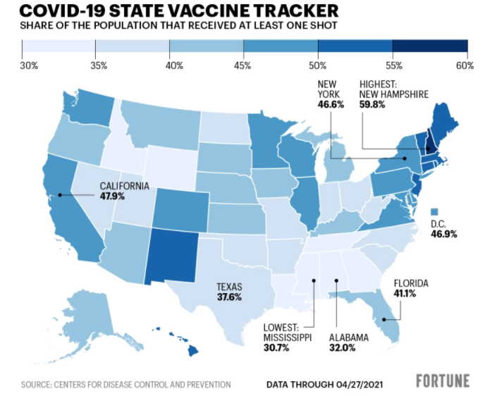

***Comprehensive Assumption***

We assume that the effective measure is mainly from vaccination right now. Other feasible solutions including wearing mask, washing hands frequently and keeping the social distances (6 inches or more per people). They will be classified into basic pandemic prevention so that the infection rate will not produce outliers.

The main applicants are only located in U.S. and narrow down in Massachusetts (MA), excluding the people who have HIV infection before, age under 18, special allergies history, and pregnant or breastfeeding women. (Due to the shortage of verification in clinical trials data and potential risk in these groups, we want to eliminate the variables, making sure each vaccine can maximize it efficacy for every user.)

For the limitation, we assume that the environment without a further virus mutation in Massachusetts, except the U.K. variant strains already exists. This measure will make sure the efficacy of vaccines can still function reasonably.

The last assumption is that every vaccinator can only use the same brand of vaccine as the second dose. In this way, we can reduce the uncertainty of utility of vaccines to make the analysis more accurate. Also, the willingness to shot and the quantity of vaccines in MA will be maintain in an average.

***Validity of Arguments and Supplement***

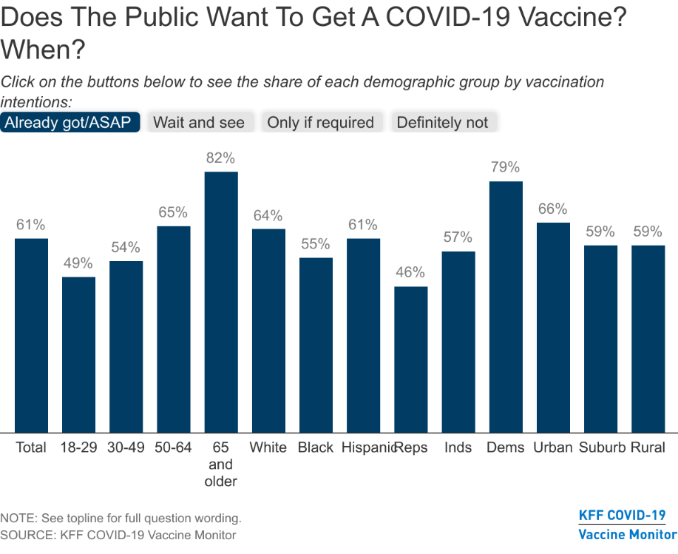

According to the figure above, there are total 61% of people would like to get a COVID-19 vaccine as the effective measure to protect themselves

from the virus. This shows that the basic pandemic prevention has not enough for them. Therefore, we will not take other feasible solution into account for this case. Compared to the figure below, we can draw a summary that the people who want get vaccine are outnumbered than the one who do not. (Total 13%)

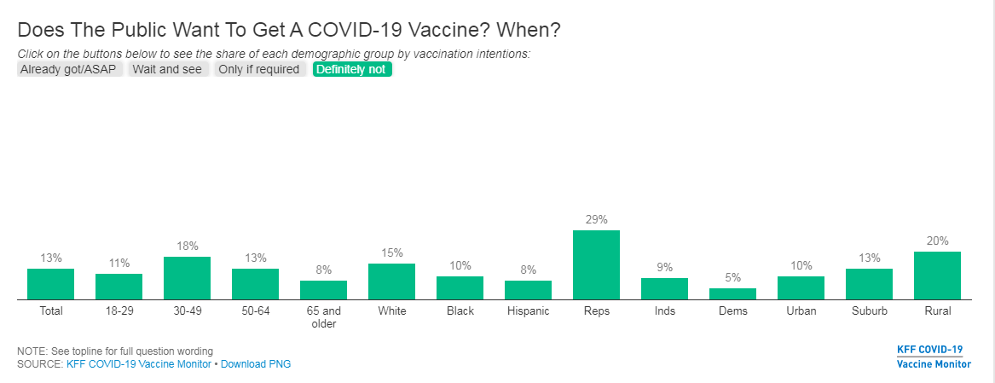

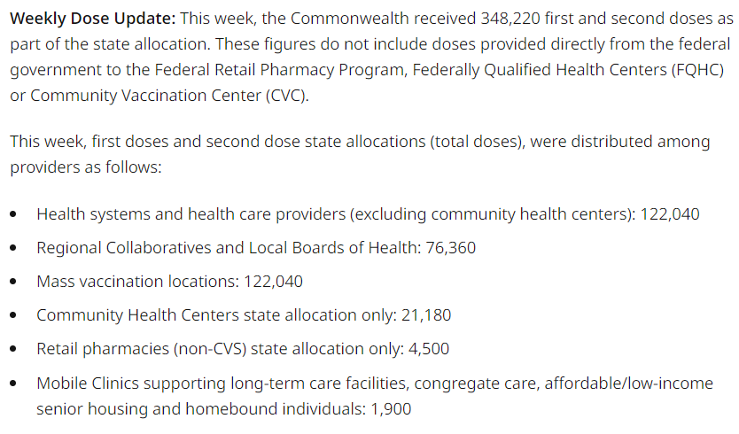

In the state government website, we can find the total amounts of vaccines about 348,200 doses are increased to different departments in April’s single week. Proving the assumption that the vaccine is sufficient is valid.

As the MA government policies, people aged 16 and older who live, work, or study in Massachusetts can be vaccinated. People who comply with regulations and hypothesis will be the essential conditions build on this case for comparing different vaccines.

***Methodology (Analysis)***

1. Formation
2. Identify the problem clearly

The main issue for this case is to determine the utility of different available vaccines in the Massachusetts, USA.

Rather put us into a random situation, we can find an optimal solution for this case. With the proper criterion, it will be easier for us to have a big picture of each vaccine and how we can make the best choice.

1. Identify the Model to Use

*Model*: Weighted Average Model

*Criterion / Parameters*:

1. Efficacy
2. Potential Risk
3. Storage management / condition
4. Other positive effect
5. Side effects
6. Dosage
7. Structure
8. Apart time

For vaccine weighting method, we want to find out which vaccine is the optimal for people to choose as the output.

1. Gathering the real-world data

The data we used for this analysis are:

Vaccine efficacy, side effects, dosage, and apart time < <https://www.yalemedicine.org/news/covid-19-vaccine-comparison>>

Comparison and choosing vaccines in states

< <https://www.bbc.com/zhongwen/trad/world-56473782>>

< <https://covid19-help.org/blog/frequently-asked-questions-about-covid-19-vaccines?gclid=Cj0KCQjwsqmEBhDiARIsANV8H3abVKz9VLiLwysKcb0PtItARh-17lTvL09jSKn8F8dxgwx8YOytpzgaAo3_EALw_wcB>>

Real-world condition in Massachusetts

<<https://www.mass.gov/info-details/massachusetts-covid-19-vaccination-data-and-updates>>

1. Solution
2. Identify the feasible solution(s)
3. Pfizer
4. Moderna
5. Johnson & Johnson
6. Evaluating feasible solutions and finding the optimal solution

Weight point for criterion:

(For the purpose of maximizing the efficacy and consider about the different features or side effects. A mediate risk with proper side effects and high efficacy solution are preferred.)

(1~10)

<Weight for choosing vaccine>

Efficacy: 7

Potential Risk: 6

Storage management / condition: 4

Other positive effect: 5

Side effects: 7

Dosage: 4

Structure: 4 (which has casual effect with potential risk)

Apart time: 3

Based on the weight criterions above, we focus on the utility and additional effects either positive or negative of the vaccines.

**Pfizer**

Efficacy: 95%

Potential Risk: Medium

Storage management / condition: Medium (2~8°C) <5D>

Other positive effect: Have the chance to deal with South Africa variant strains.

Side effects: High

Dosage: 2

Structure: mRNA (new generation) < SARS CoV-2>

Apart time: 28D

**Moderna**

Efficacy: 94%

Potential Risk: Medium

Storage management / condition: Easy (2~8°C) <30D>

Other positive effect: None (still under experimenting)

Side effects: Medium

Dosage: 2

Structure: mRNA-1273 (new generation) < SARS CoV-2>

Apart time: 24 to 42D (33D as average)

**Johnson & Johnson**

Efficacy: 72%

Potential Risk: High (causing blood clots)

Storage management / condition: Easy (2~8°C)<35D>

Other positive effect: Have the chance to deal with South Africa variant strains and other common diseases.

Side effects: Light

Dosage: 1

Structure: carrier (current generation)

Apart time: 0D (no apart time)

1. Testing the results

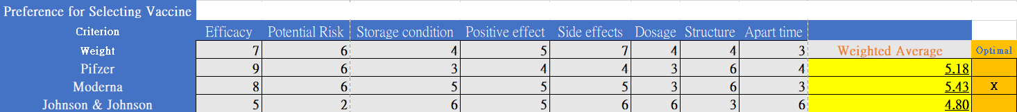

As the figure above, through the weight average method, we can find out the optimal solution is Moderna (5.43).

1. Sensitivity analysis

To conduct a sensitivity analysis, we need to scope down the important factors which are the criterion inside this model. We take efficacy, side effect and positive effect into account, because they have a high correlation with the outcome.

For sensitivity analysis, we first change the parameter of the weight of Positive effect.

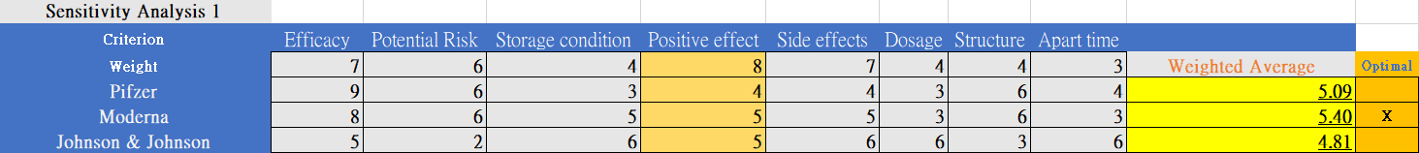

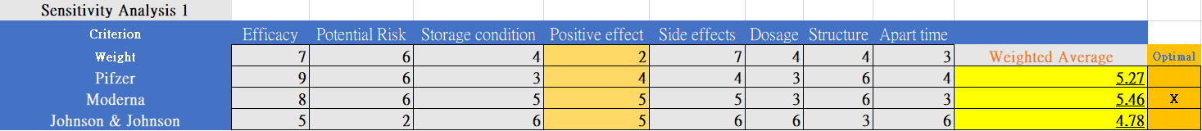

As an entry point, we want to determine whether changing this parameter will conduct a drastically difference in output. So, we change the Positive effect into 8 and 2. As we observed, the outcome changed slightly, Moderna still remain as the optimal solution.

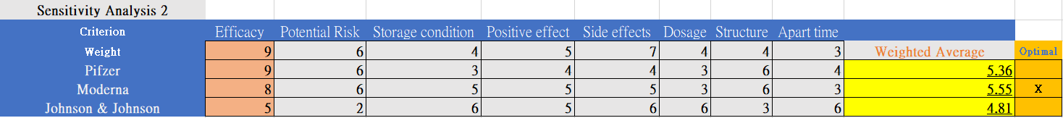

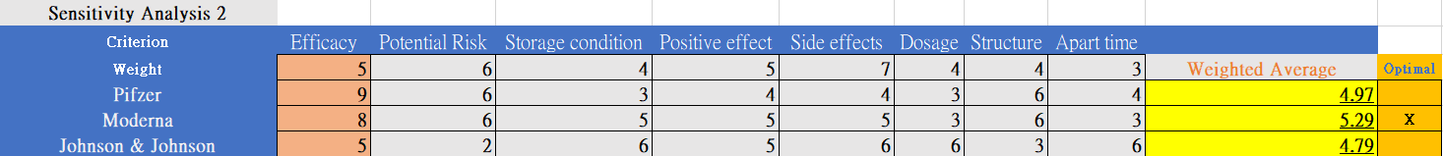

As the figure above, we change the Efficacy as the parameter in second sensitivity analysis. Through increasing and decreasing the parameters, we found out there is a significance correlation between the Pfizer vaccine and its output. Also, the solution is still the same.

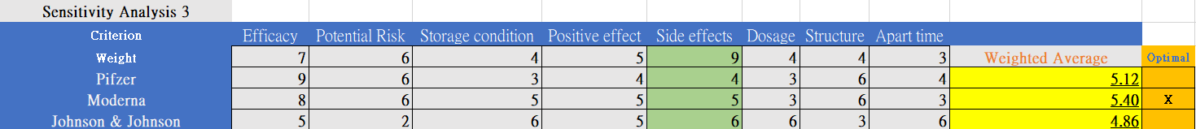

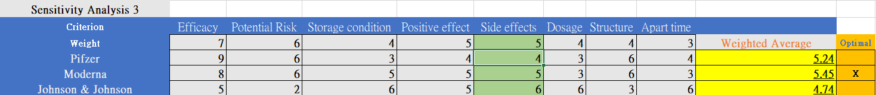

For the third sensitivity analysis, we use Side effect as the parameter. The output shown that this parameter has less significance in all of the alternatives.

***Recommendation / Examination***

Based on each criterion in the model, we also can see the decisive factors, such as Positive effect, Side effect and efficacy have contributed a lot to this decision making.

After taking the sensitivity analysis above into account, we revised the index of weight average model slightly to fit the real-world situation.

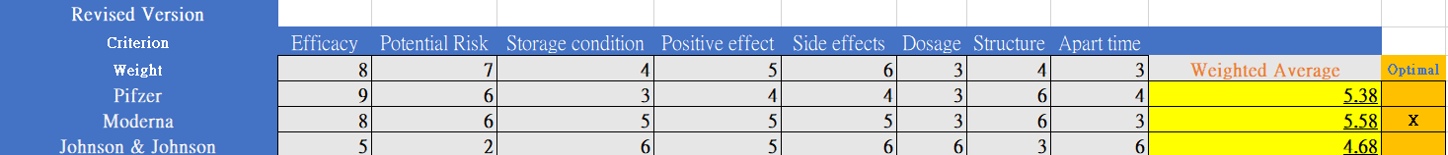

For our analysis purpose, we need to adjust our parameters slightly to make sure the output has closer to real-world circumstance. In other words, we need to make the criteria fit the high efficacy and low risk & side effects. Other parameters like dosage and apart time, they might the one which will influence the decision making but still not significance between the correlation and purpose.

Thus, we adjusted efficacy from 7 to 8, Potential risk from 6 to 7, and Side effect from 7 to 6. Other parameters were also fixing a little bit. To quickly sum up, the implementation of choosing optimal vaccine will be Moderna in Massachusetts.

In my point of view, the use-case model can only particularly reflect the current demands and total environment need. If we want a more accurate and precisely output, we need more clinical trials and information including the vaccines still under development and wait for the overview data of vaccines in this case to have a better understanding in detail.

***Conclusion***

The purpose of this case is to determine the usage and utility of each available vaccine in Massachusetts, U.S. After detailed comparison, the optimal solution would be Moderna with 2 dosage and 33 days of apart time in average.

Although there are many countries and regions still under emergency situations and need as many as vaccines they could, including my country: Taiwan. With proper action, everyone should have vaccination as soon as possible. However, we still hope this case can help someone who are wondering which current type of vaccine can work the best for them.

***References***

<https://covid19-help.org/blog/frequently-asked-questions-about-covid-19-vaccines?gclid=Cj0KCQjwsqmEBhDiARIsANV8H3abVKz9VLiLwysKcb0PtItARh-17lTvL09jSKn8F8dxgwx8YOytpzgaAo3_EALw_wcB>

<https://fortune.com/2021/04/28/covid-vaccine-tracker-update-us-state-by-state-pfizer-moderna-johnson-and-johnson-data-coronavirus-vaccines-april-2021/>

<https://www.yalemedicine.org/news/covid-19-vaccine-comparison>

<https://www.bbc.com/zhongwen/trad/world-56473782>

<https://www.bbc.com/ukchina/trad/55890129>

<https://chinese.cdc.gov/coronavirus/2019-ncov/vaccines/keythingstoknow.html>

<https://www.kff.org/coronavirus-covid-19/dashboard/kff-covid-19-vaccine-monitor-dashboard/?gclid=Cj0KCQjwsqmEBhDiARIsANV8H3alle2G2tM3oKK6r321qQIj2ahUyYaFB0LncKEVIu06Ny2773v9DDIaAlFMEALw_wcB>

<https://getvaccineanswers.org/question/vaccine-safety?gclid=Cj0KCQjwsqmEBhDiARIsANV8H3ZKl1IceysMuoRa2k0ncoLAxJj1hAChuZSDgto-b4iUwjeiQ9QWkIQaAqEzEALw_wcB#how-were-the-vaccines-made-so-quickly>

<https://www.mass.gov/info-details/massachusetts-covid-19-vaccination-data-and-updates>

<https://www.mass.gov/info-details/massachusetts-covid-19-vaccine-information>

<https://www.fda.gov/media/144414/download>

<https://www.pfizer.com/news/hot-topics/the_facts_about_pfizer_and_biontech_s_covid_19_vaccine>

<https://www.fda.gov/media/146305/download>

<https://www.mass.gov/doc/weekly-covid-19-vaccination-report-april-29-2021/download>

<https://www.nbcboston.com/news/local/covid-variants-raising-questions-about-mass-reopening-safety/2353836/>

<https://www.youtube.com/watch?v=_j_gciVGSiA&list=PLbpi6ZahtOH4EwdSWEkBnsEgYpAfp1Yuc>

<https://www.forbes.com/sites/ellenmatloff/2020/12/18/what-are-the-long-term-safety-risks-of-the-pfizer-and-moderna-covid-19-vaccines/?sh=275f5a968f3d>

<https://www.cdc.gov/vaccines/covid-19/info-by-product/janssen/downloads/janssen-storage-handling-summary.pdf>